Profile

A highly organized and detail-oriented professional with over 2+ year hands-on experience, providing skilful recruitment support to clients. I am Independent and self-motivated person with an ability to develop positive relationships with clients and colleagues at all organizational levels. Displayed excellence in managing the entire recruitment lifecycle spanning sourcing candidates from various sources (Job portals, Personal network, Employee reference, Walk-ins, Open source & Direct sourcing) short listing candidates, conducting interviews, completing joining formalities and background verification.



Education

**Jaya Engineering College, Thiruninravur (2012 – 2014)**

Master of Business Administration (78%)

**Specialization**: Human Resource Management& Finance

**Jaya Arts & Science College, Thiruninravur (2009 - 2012)**

Bachelor of Commerce (65%)

**Specialization**: Commerce (General)

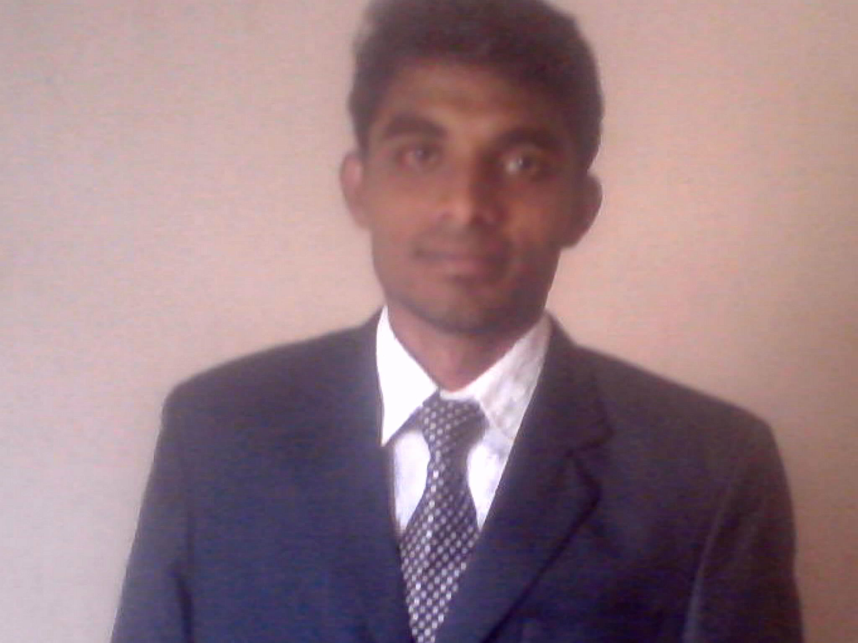

**SARAN KUMAR L**

* 14, Vivekananda Nagar, 5th Street. Gummidipoondi – 601201.



**0 99 44 678 618**



**sarankumarstar@gmail.com**



**in.linkedin.com/pub/sarankumarstar**

 sarankumar.l

**St. Mary’s High school, Gummidipoondi, (2009)**

HSC (62%)

**St. Mary’s High School, Gummidipoondi, (2007)**

SSLC (56%)



Experience

**Vijay Soft Solution (P) Ltd**

***(May 2014 - Sep 2015) – 1.4 Years***

***Human Resource Executive & Business Development Executive.***

**Aargee Staffing Services (P) Ltd**

***(Oct 2015 – At Present)***

***Sr.Human Resource Executive / Client relation Executive***

**Areas of Expertise**

* Talent Acquisition
* Client Acquisition
* Profile Sourcing
* Head Hunting
* Campus Recruitment
* Drive Coordination
* Handling HR Responsibilities
* Training & Supervising Personnel

**Overview - Job Profile**

**Vijay Soft Solution (May 2014 to September 2015)**

***Role - Human Resource Executive / Business Development Executive***

* Document verification for new joinees.
* Id cards preparation.
* Prepared offer letters, joining letters & appointment letters as per department needs.
* Plan, organize, and conduct induction programmed for the new joiner.
* Complete the joining formalities i.e. collect the required documents, creation of login id for attendance and working on forms and letters.
* To induct and orient the new recruits to the organizational culture, respective business unit.
* People Engagement
* Handling reward, recognition & Events
* Co-ordinating with Payroll team
* Leave & Attendance maintenance.
* HR/Recruitment/Talent Engagement professional experience in Talent Acquisition, IT/Non IT recruitment, Staffing, Campus Recruitment etc.
* Proficient level of knowledge in Full Lifecycle Recruiting components, Sourcing, Screening, Qualifying, Networking, Assessing, Job Analysis, Wage and Salary Trends, Relationship Management and due diligence.
* End to end recruitment, requisition approval, creating job postings, sourcing resumes/candidates, reviewing resumes, conducting telephone interviews, extending offers, salary negotiations, and reporting/tracking data, recruitment drive, walk-ins and employee referral, job portals, personal network, open source, direct sourcing.
* Excellent understanding of recruitment techniques and methodologies full cycle, multi-function, Team Management, Bulk Hiring, Lateral/Vertical Hiring and Client co-ordination.
* CV Screening/Sourcing
* Active and Passive candidate sourcing from Job Boards, Internet, LinkedIn, Creative Websites, etc.
* Job Posting and CV response management
* Consulting the client on sourcing / recruitment strategy
* Analysis of the existing sourcing process, identifying key areas of improvement and providing effective solutions, thus improving the outcome
* Involved in coordinating with candidates for Interview scheduling.

**Overview - Job Profile**

**Aargee Staffing Services Pvt Ltd (October 2015 to At Present)**

**About**

We are a small but focused staffing and recruitment company based in Chennai. We have been in the field for 12 years, and over this period have built a solid reputation in servicing our clients. We specialise in placing staff for the BPO, Call centre, IT and Manufacturing. We also place software programmers, project lead and BDM in our client companies.

We operate across the entire country. We can source staff for you in Delhi, Kolkata, Mumbai, Chennai, Bangalore, Hyderabad and other state capitals as well as tier 2 cities. We have offices in three cities (Chennai, Ahmadabad & Kolkata) and associates in other cities to manage the recruitment process.

**Role** – **Sr. Human Resource Executive & Client Relation Executive**

* Maintenance of job postings on the Job portals.
* Planning and managing Recruitment Activities for Business Team.
* Expertise in Entire Recruitment Life Cycle from Sourcing, Screening, Selection, pre selection Process.
* Sourcing and screening candidates through Naukri, Monster, LinkedIn with creative sourcing techniques which include Self- created database, referral generation, own network of contacts and Job portals.
* Screening the profiles, short listing and selecting the candidates in the preliminary rounds.
* Briefing the candidates about the job profile, package, organization, etc.
* Follow up with candidates for interviews and joining.
* Preparing Daily, Weekly and Monthly Reports.
* Meeting Corporate and bringing new clients for Recruitment
* Identifying new clients for business proposals in IT Industry and Non IT Industry in Domestic
* Interacting with the clients on regular basis.

**Thanks & Regards**

**Place: Chennai Saran Kumar L**

**Date:**